**Connect your Outlook calendar to Zoom**

(to be able to see all your calendar events in Zoom and not just your Zoom events)

1. Open the Zoom client on your computer and click on the link ”connecting your calendar” that is in the calendar part of the first page (the Home tab) when you open Zoom

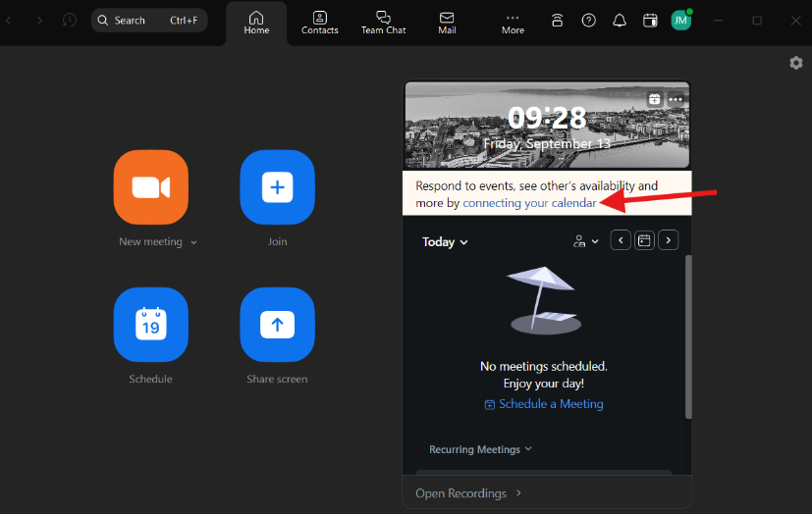

1. Select the option Microsoft

1. Your default web browser will now open a window to get you to the web page for Zoom and at that page you should click Continue

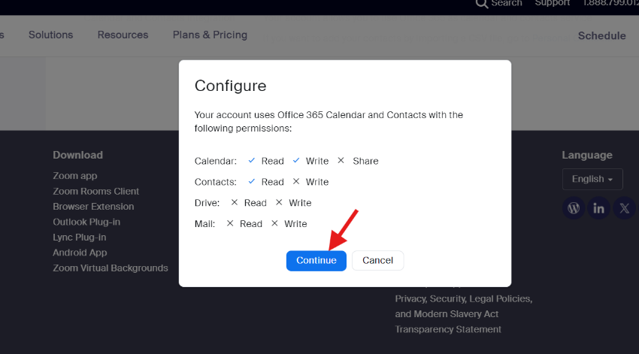

1. Now you should be able to see todays events on the start page of the Zoom client on your computer and all of your Outlook calendare in the tab Calendar (if you don’t see any meetings in the tab Calendar, make sure that the check box by the calendar option in the left menu is checked)

